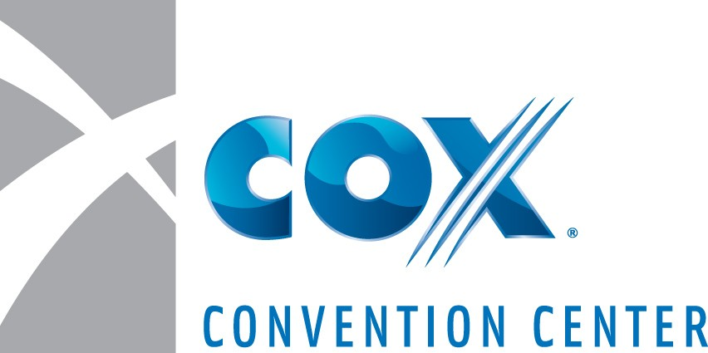

AUTHORIZATION REQUEST
SAMPLE FOOD AND/OR BEVERAGE DISTRIBUTION
SAVOR… has the exclusive food and beverage distribution rights within Chesapeake Energy Arena and the Cox Convention Center. Exposition sponsoring organizations and their exhibitors may distribute SAMPLE food or non-alcoholic beverage products with written authorization ONLY.
GENERAL CONDITIONS:
- Items dispensed are limited to products manufactured or produced by the exhibiting firm.
- All items distributed are limited to sample sizes:
a. Beverages limited to maximum of 4 oz. Containers.
b. Food items limited to “bite size” individually wrapped: (3 oz. or less).
- Use of cooking equipment must have prior approval of the Chesapeake Energy Arena and Cox Convention Center.
- Show management or exhibitor is responsible for securing an Oklahoma City Health Permit and a Special Event Permit License. Permits must be obtained in order to distribute food and beverages.
- Standard fees for storage, handling, delivery, etc. will be charged where applicable.
- Food and beverage items used as traffic promoters (i.e. coffee, popcorn, bottled waters, sodas, bar service, etc.) MUST be purchased from SAVOR. Please contact our Catering office with questions on traffic promotions items, please see numbers listed below.
- The applicant named below acknowledges they have sole responsibility for use, service, and disposition of such items in compliance with all applicable laws. State law prohibits the sampling and distribution of alcoholic beverages. Accordingly, the applicant agrees to indemnify and forever hold harmless SAVOR…, Chesapeake Energy Arena & Cox Convention Center, the City of Oklahoma City and its agents from all liabilities, damages, losses, costs or expenses resulting directly or indirectly from their use distribution or other dispensed food and beverage items.

Name of Event________________________________________________Event Date(s)________________________

Firm Name____________________________________ Telephone___________________Fax ___________________

Address __________________________________________________________________________________________

City __________________________________________State_________ Zip Code ____________ Booth # ________

On Site Contact _____________________________________________ Title _________________________________

Signature_____________________________________________________________ Date _______________________
Product(s) you wish to dispense ____________________________________________________________________

Size of portion to be dispensed ____________________________________ Quantity Distributed _____________

Proposed method of dispensing and reason for offering samples _______________________________________
SERVICES REQUIRED: Please notify SAVOR… at (405) 602-8608, regarding any special services or requests related to your sample distribution. You may also email this completed form to the Tracey Leird / email: tleird@coxconventioncenter.com. A state tax applies to all charges and service charge where applicable.

NOTE: All samples MUST receive prior approval and confirmation from the Show Manager, SAVOR… and Chesapeake Energy Arena and Cox Convention Center. Exhibitors who do not comply will be asked to remove the items from the facility.

APPROVED___________________________________ APPROVED ______________________________
Director of F&B, SAVOR… Sales Manager, SAVOR…
PLEASE RETURN TO OUR CATERING OFFICE
AT LEAST TWO WEEKS PRIOR TO THE START OF THE SHOW.

